Field | Description
Defect ID | 01
Title/Summary | Employee name and User name accepts numbers and special characters
Description | Employee name and User name should only be text it should not  Accept number or special characters
Steps to Reproduce | 1. Login using admin credentials  User name ; Admin  Password : admin123  2. Click on add user  3. Enter user role "ESS"  5. Enter user name "@1234"  6. Enter status "Enabled"
Expected Result | Employee name, user name should not accept any numbers or special characters
Actual Result | Special characters are getting accepted in employee and user name text box
Severity | Medium
Priority | High
Environment | Chrome browser

Evidence
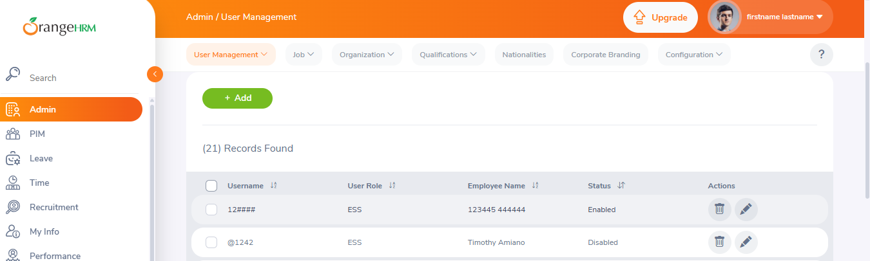

Field | Description
Defect ID | 02
Title/Summary | Employee unable to apply for leave
Description | Employee unable to create leave request with  necessary details
Steps to Reproduce | 1. Login using employee credentials  User name ; suriya  Password : Testemp@123  2.Click on leave  3.Click on Apply
Expected Result | Employee should able to apply for leave by adding necessary information
Actual Result | Employee not able to apply for leave.The fields are not displaying in the leave tab
Severity | High
Priority | High
Environment | Chrome browser

Evidence
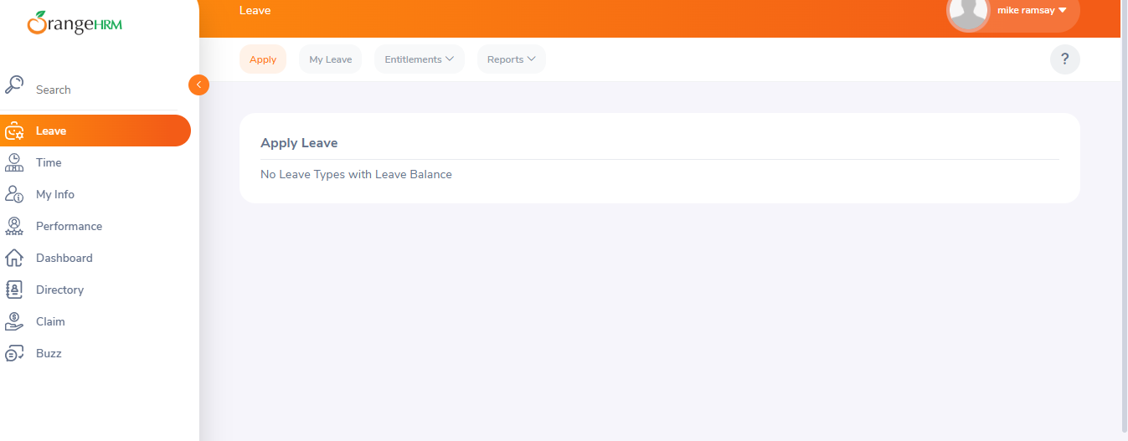

Field | Description
Defect ID | 03
Title/Summary | Employee punch in and out time accepts  same value
Description | Employees While entering attendance , are able to enter punch in and out time same.
Steps to Reproduce | 1. Login using employee credentials  User name ; suriya  Password : Testemp@123  2.Click on Time  3.Click on Attendance  4. Click on Punch in/out  5. Enter date "26102026"  6. Enter in time "6.25 AM"  7. Enter out time "6.25AM"
Expected Result | Employee should able to add  in time and out time and they should be different
Actual Result | Employee in / out time accepting same  values
Severity | Medium
Priority | Medium
Environment | Chrome browser

Evidence



